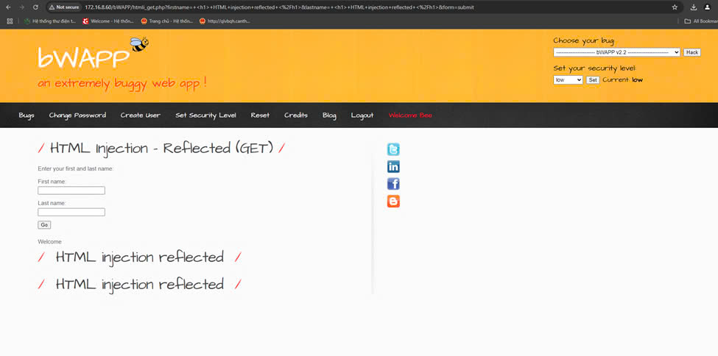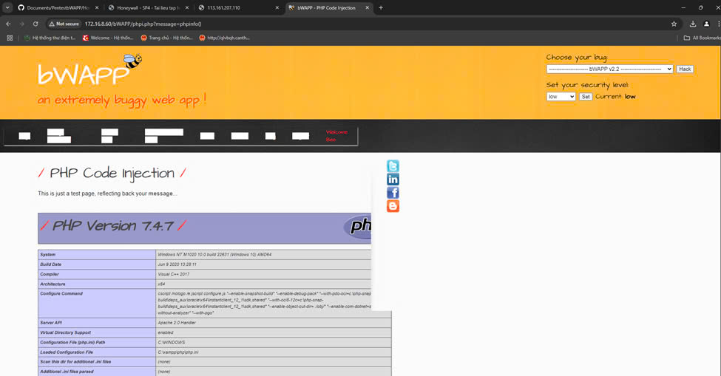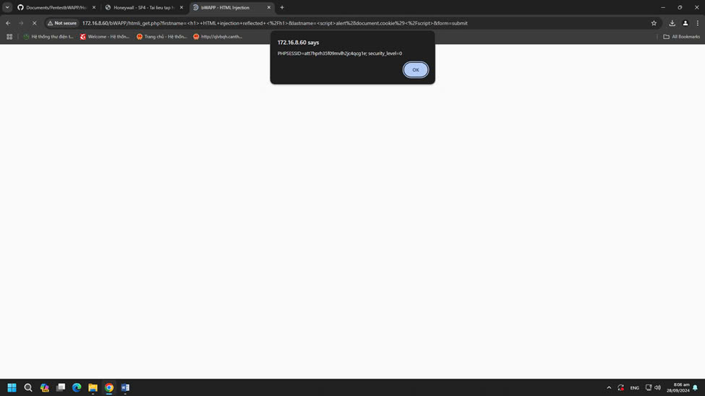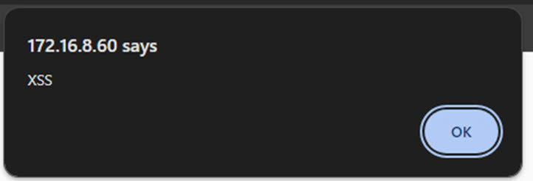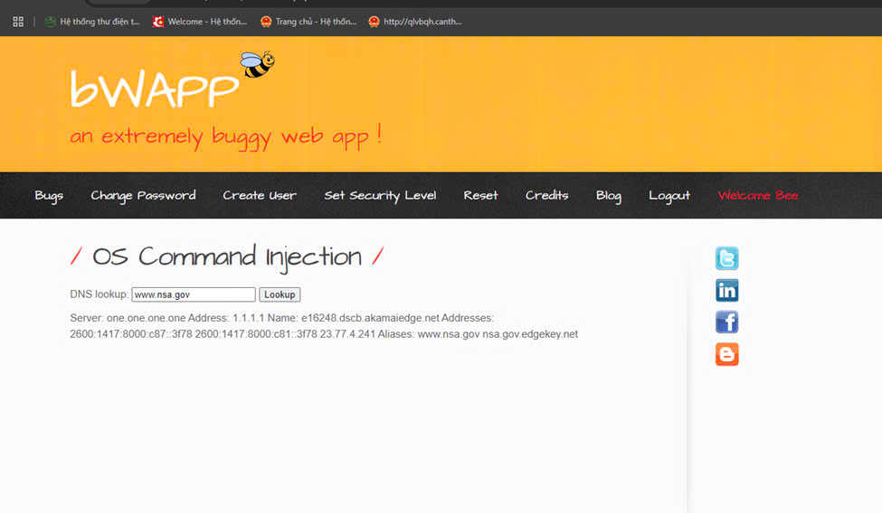

OS: Windows 10 (version 1809)/Windows Server 2019 (version 1809)

